Organization security policy framework
Objective: To establish the organization’s attitude toward security and define the necessary actions to protect its resources and assets. This policy forms the basis for establishing security tools and procedures and determines the roles and responsibilities of employees in ensuring security.
Key questions:
- The three main components of a security policy framework (basic policy, specialized policies, procedures)
- The core documents describing the security policy (review, description, architecture guide)
- Defining a Basic Security Policy
- Types of Specialized Security Policies (user-affecting vs. technical areas)
- The relationship between Security Policies and Security Procedures
- The Event Response Procedure as a key example

Brief summary: For most organizations, a security policy is absolutely necessary. It determines the organization’s attitude to security and the organization’s necessary actions to protect its resources and assets. Based on the security policy, the necessary security tools and procedures are established, and the roles and responsibilities of the organization’s employees in ensuring security are determined.
Typically, an organization’s security policy includes:
- basic security policy;
- specialized security policies;
- security procedures.
The main provisions of the organization’s security policy are described in the following documents:
- security policy review - discloses the purpose of the security policy , describes the structure of the security policy, sets out in detail who is responsible for what, establishes procedures and the estimated time frame for making changes. Depending on the size of the organization, a security policy may contain more or less sections;
- basic security policy description - determines the time resolved and prohibited activities and the necessary controls, as part of the security architecture;
- security architecture guide - describes the relation of security mechanisms in the components of architectures used in the organization of the network.
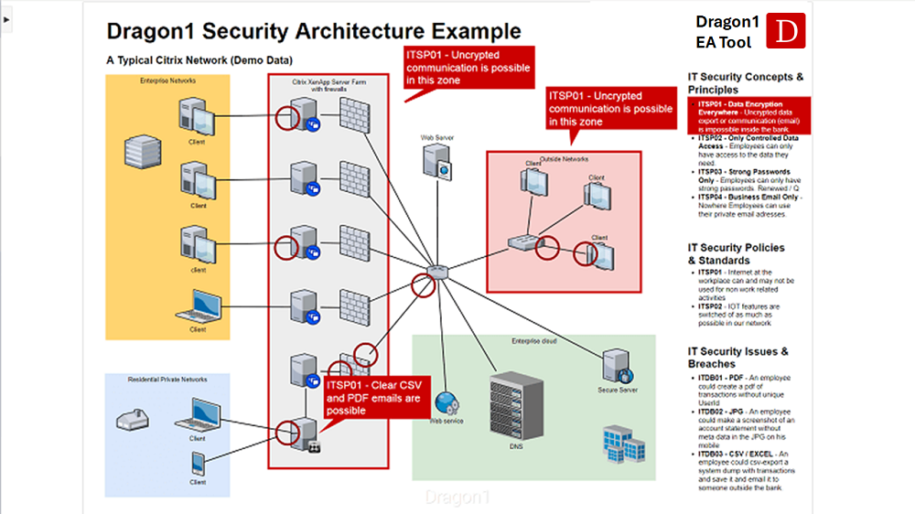

1. Basic security policy
A basic security policy defines the fundamental rules by which an organization processes, stores, and exchanges information. It outlines who is allowed to access specific data, under what conditions this access is granted, and what procedures must be followed to ensure proper protection. In essence, it serves as the foundation for all information security activities within the organization.
Using a top-down approach, the basic security policy enables an organization to build its security system gradually and systematically, without attempting to solve all issues at once. It creates a clear framework that guides the development of more detailed security mechanisms and technical measures. Because the policy is documented and regularly updated, employees can refer to it at any time to understand the full scope of the organization’s security requirements and to assess the current level of protection.
The structure and content of a basic security policy depend on the organization’s size, operational complexity, and strategic objectives. In small companies, the policy may be relatively concise, focusing on essential security rules. In larger enterprises, it typically becomes more comprehensive and organized into multiple sections addressing different aspects of security.
Generally, a basic security policy is supported by a system of specialized policies, standards, and procedures. These include policies for access control, password management, data classification, incident response, network security, physical protection, and many others. Together, they form a unified framework that ensures the organization adheres to consistent security practices and complies with internal and external requirements.
1. 1 . Specialized Security Policies
There are potentially dozens of specialized policies that can be applied by most medium and large organizations. Some policies are designed for each organization; others are specific to certain computer environments.
Considering the application features, specialized security policies can be divided into two groups: policies affecting a significant number of users, and policies related to specific technical areas.
Specialized policies affecting a significant number of users include: acceptable use policy, policy of remote access to network resources, information security policy, password protection policy, etc.
Specialized policies related to specific technical areas include: firewall configuration policy, encryption and cryptographic key management policy, and security policy of virtual secure VPN networks.
1. 2 . Safety procedures
Security procedures are a necessary and important complement to security policies. Security policies only describe what should be protected and what are the basic rules for protection. Security procedures determine how to protect resources and what are the mechanisms for enforcing policies, i.e., how to implement security policies.
Essentially, security procedures are step-by-step instructions for performing operational tasks. Often, a procedure is the tool by which a policy is transformed into a real action. For example, a password policy formulates rules for constructing passwords, rules on how to protect a password and how often to replace it. The password management procedure describes the process of creating new passwords, their distribution, as well as the process of guaranteed change of passwords on critical devices.
Safety procedures detail the actions to be taken in responding to specific events; provide quick response in critical situations; help eliminate the problem of a single point of failure in work if, for example, during a crisis, an employee unexpectedly leaves the workplace or is inaccessible.
Many security related procedures should be standard tools in any department. As examples, you can specify the procedures for backing up and off-system storage of protected copies, as well as the procedures for removing a user from the active state and / or archiving the user's login and password, which are applied immediately as this user leaves the organization.
Consider several important security procedures that are required by almost every organization.
An event response procedure is a necessary security tool for most organizations. An organization is particularly vulnerable when an intrusion into its network is detected or when it is confronted with a natural disaster.
Procedures for responding to events is sometimes called proce event processing fool or a procedure to respond to the incident to denta. Impossible to provide responses to all soby ment security breaches, but should strive to reach the overwhelming burden the types of violations that may occur. For example: network port scan, denial of service attack, compromised host, unauthorized access, etc.
This procedure determines: responsibilities of response team members; what information to record and track; how to handle the study of abnormalities and intrusion attacks; whom and when to notify; who can publish information and what is the procedure for the release of information; and how the subsequent analysis should be carried out and who will participate in it.
Review questions:
- What is the main purpose of an organization's security policy?
- What are the three typical components of an organization's security policy framework?
- What is the difference between a "basic security policy" and a "specialized security policy"?
- Explain the relationship between security policies and security procedures. Why are both necessary?
- What key elements should an event response procedure define?
Recommended literature list:
- Landoll, D. (2021). Information Security Policies, Procedures, and Standards: A Practitioner's Reference. CRC Press.
- Straub, D. W., Goodman, S. E., & Baskerville, R. (2008). Information Security: Policy, Processes, and Practices. M.E. Sharpe.
- Paananen, H., & Siponen, M. (2019). Information security policy: An organizational-level process model. Proceedings of the 52nd Hawaii International Conference on System Sciences.

